# **Documentation**

# **Introduction:**

### ***Telecall Scenario:***

**Telecall** is a Jordanian Telecommunication Company that wants to be a pioneer telecommunication company In Jordan. The company provides internet services to the Customers in all of the governorates.

The company has a Head Quarter located in Alshmeisani and has four departments (Sales, Accounting, HR, and Customer Services) and each department has many employees. The employee works only for one department while the department can have multiple employees.

Employees serve customers that want to buy internet subscriptions or pay their bills. Also.

There are multiple subscription types (Fiber 50Mbps, 4G Home 1000G,5G home 500 GB, DSL Home 500 GB, MIFI 100 GB), and each subscription is assigned to one of these subscription types.

REASON AND WORK DISTRIBUTION:

**The reason we chose the idea, is that one of our members worked for Umniah**

**so he had a good background in telecommunication companies.**

**After we agreed on the idea we distributed the work into two groups, one works on the documentation and interface (Rand, Leen), and the second one works on the coding (Yaman, Ahmad).**

*Entities:*

1. Customer (**ID** NUMBER UNIQUE, **F_Name** VARCHAR2, **L_Name** VARCHAR2, **Address** VARCHAR2, **SSN** NUMBER, **Phone_Number** NUMBER).
2. Employee (**ID** NUMBER, **SSN** NUMBER, **BIRTH_DATE** DATE, **F_Name** VARCHAR2, **L_Name** VARCHAR2, **Salary** NUMBER, **Email** VARCHAR2).
3. Project (**Department** FOREIGN KEY, **ID** NUMBER, **Name** VARCHAR2, **Budget** NUMBER).
4. Department (**Name** VARCHAR2 UNIQUE, **Department_ID** NUMBER PRIMARY KEY).
5. Subscriptions (**Name** VARCHAR2,**Subscription_type** VARCHAR2, **Bill_ID** NUMBER FOREIGN KEY, **Date_of_purchise** DATE, **End_Date** DATE, **Price** NUMBER).

1. Bill (**ID** NUMBER PRIMARY KEY, **Price** NUMBER, **Cusomer_Name** VARCHAR2, **Type_of_subscribtion** VARCHAR2).

*Requirements:*

* Each **Customer** can have many **Subscriptions** while each **Subscription** can have multiple **Customers**.
* Each **Customer** can pay many **Bills** while exactly one **Customer** pays each **Bill**.
* Each **Subscription** has one **Bill** and exactly one **Bill** has one **Subscription**.
* Each **Employee** works in precisely one **Department** while **Department** can have many **Employees**.
* Each **Employee** may perform on a **Project** and each **Project** should be performed by many **Employees**.
* Each **Department** may control many **Projects** while each **Project** controlled by exactly one **Department**.

*ERD:*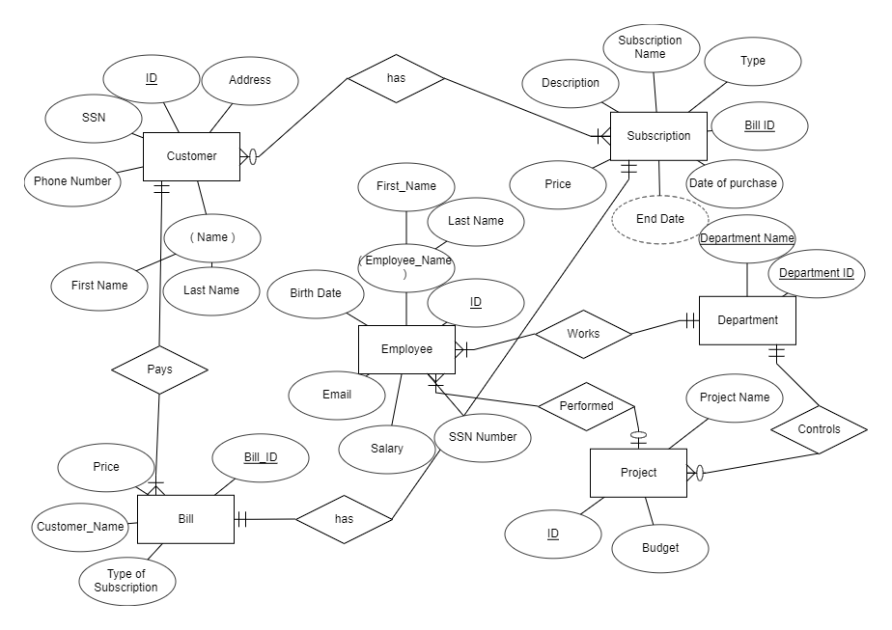

*Relational schema:*

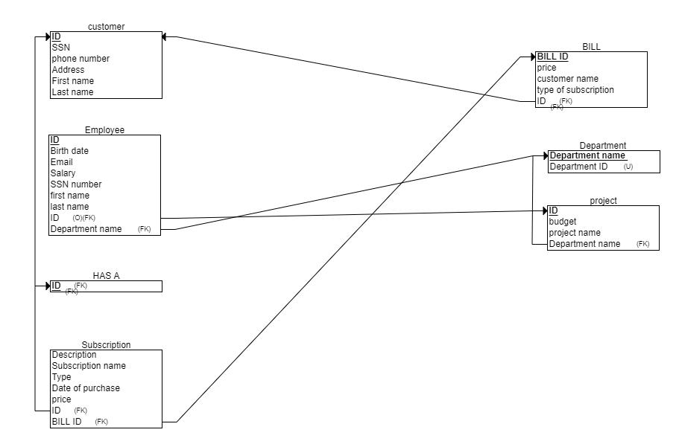

***Coding part (Double click the box):***



*INTERFACE*

***Connection.php (Double click the box):***

**

***Index.php (Double click the box):*****

*In this file we used the connection.php file to connect to our localhost*

*And we used the employee table to retrieve the email which we used as*

*User name and employee id as a password as shown below :*

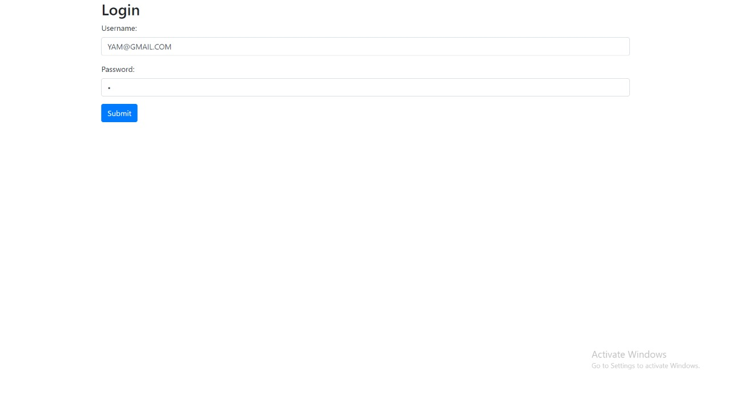

***Home.php (Double click the box):*********

*After pressing the submit button, it will take us to the home page and on the home page it will show us the customer’s information.*

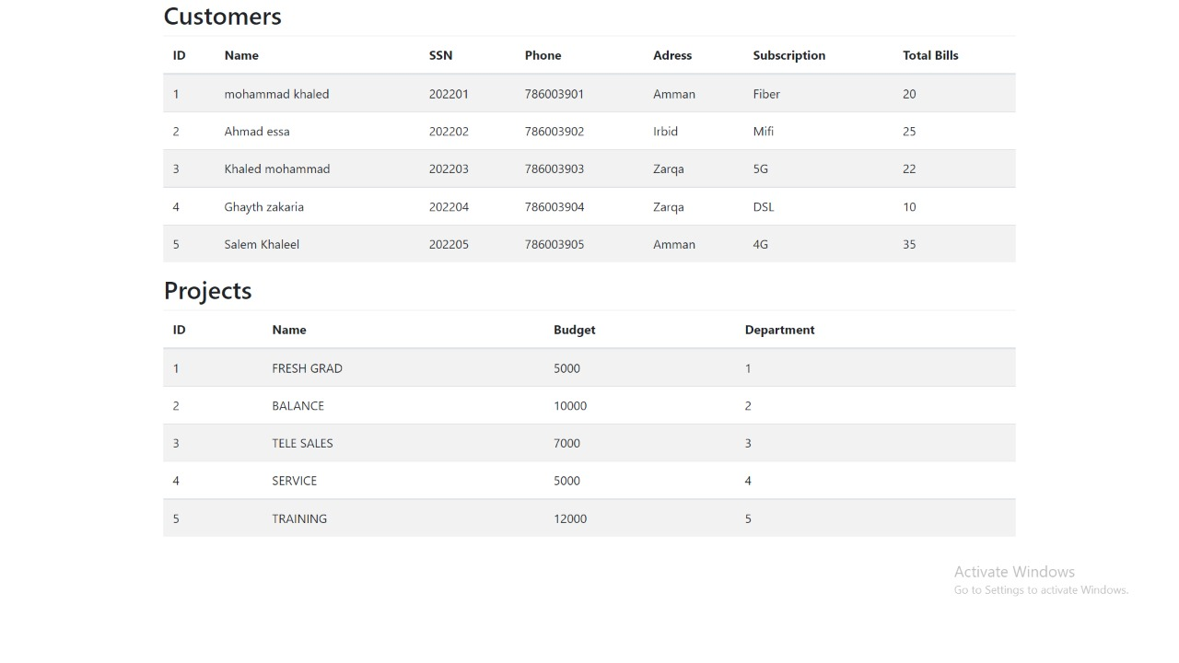

***Thank you:***

Yaman Sameer **20200535**

Ahmad Awwad **20201145**

Rand Alshoubaki **20200956**

Leen Daqa **20200575**